Task 2: Master Data Requirements
Master data admin sent for you an email requesting your requirements regarding SMF & VMF with justification why you need such requirement.

Task 3: add or remove
One of the suppliers offered you the below two products to be add in weight management category with margin 60%. Kindly take the decision and build full IMF if you approve.
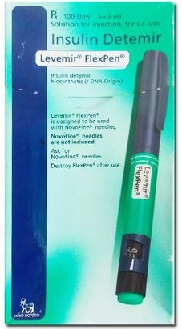 | 

Answer

